# Object Oriented Programming

# Project Documentation



Submitted by:

RIFFAQAT HUSSAIN

Submitted to:

Ma’am Sadaf Anwar

Faculty of Engineering & Computer Sciences

Department of BSIT Morning 2nd Semester

National University of Modern Languages, Islamabad

Online course registration

My project is about **online course registration**.

I have made two panels in the first frame, one for login and the second one for the signup. I used this because new users must register them and then apply for any course they want.

In the second frame, I display some options regarding the user information and the course.

In the last frame, I display the list of students who have been registered on our platform.

Frame 1

package Login;

import javax.swing.*;

import java.awt.*;

import java.awt.event.*;

import java.sql.*;

import Login.Frame2;

public class Frame1 {

public static void main(String[] args) {

JFrame f=new JFrame("welcome to R.H 210");

ImageIcon img=new ImageIcon("C:\\Users\\RIFFAQAT ALI\\Desktop\\login\\guifinal1.jpg");

JPanel panel = new JPanel();

panel.setBackground(new Color(0, 0,0, 0));

panel.setBounds(781, 220, 456, 533);

f.add(panel);

panel.setLayout(null);panel.setVisible(true);

JLabel lblLogin = new JLabel("Login ");

lblLogin.setHorizontalAlignment(SwingConstants.CENTER);

lblLogin.setForeground(Color.CYAN);

lblLogin.setFont(new Font("Bauhaus 93", Font.BOLD, 94));

lblLogin.setBounds(20, 11, 426, 121);

panel.add(lblLogin);

JLabel PleaseLogin = new JLabel("Please sign in with your R.H 210 account");

PleaseLogin.setHorizontalAlignment(SwingConstants.CENTER);

PleaseLogin.setForeground(SystemColor.activeCaption);

PleaseLogin.setFont(new Font("Arial Rounded MT Bold", Font.PLAIN, 15));

PleaseLogin.setBounds(60, 130, 363, 39);

panel.add(PleaseLogin);

JLabel l1 = new JLabel("Username");

l1.setHorizontalAlignment(SwingConstants.CENTER);

l1.setForeground(new Color(0, 255, 255));

l1.setFont(new Font("Arial Rounded MT Bold", Font.PLAIN, 20));

l1.setBounds(20, 192, 183, 39);

panel.add(l1);

JTextField t = new JTextField();

t.setFont(new Font("Arial", Font.PLAIN, 20));

t.setBackground(new Color(220, 220, 220));

t.setBounds(213, 195, 210, 39);

panel.add(t);

//t.setColumns(10);

JLabel l2 = new JLabel("Password");

l2.setHorizontalAlignment(SwingConstants.CENTER);

l2.setForeground(Color.CYAN);

l2.setFont(new Font("Arial Rounded MT Bold", Font.PLAIN, 20));

l2.setBounds(20, 294, 183, 39);

panel.add(l2);

JPasswordField passwordField = new JPasswordField();

passwordField.setForeground(new Color(0, 0, 0));

passwordField.setFont(new Font("Tahoma", Font.PLAIN, 20));

passwordField.setBackground(new Color(220, 220, 220));

passwordField.setBounds(213, 297, 210, 39);

panel.add(passwordField);

JLabel DontHaveAny = new JLabel("Don't have any account?");

DontHaveAny.setHorizontalAlignment(SwingConstants.RIGHT);

DontHaveAny.setForeground(SystemColor.activeCaption);

DontHaveAny.setFont(new Font("Arial Rounded MT Bold", Font.PLAIN, 15));

DontHaveAny.setBounds(140, 457, 216, 39);

panel.add(DontHaveAny);

//sign up panel start from here

JPanel panel1 = new JPanel();

panel1.setBackground(new Color(0, 0,0, 0));

panel1.setBounds(780, 220, 456, 533);

f.add(panel1);panel1.setLayout(null);panel1.setVisible(false);

JLabel signup = new JLabel("Sign up");

signup.setHorizontalAlignment(SwingConstants.CENTER);

signup.setForeground(Color.CYAN);

signup.setFont(new Font("Bauhaus 93", Font.BOLD, 94));

signup.setBounds(20, 11, 426, 121);

panel1.add(signup);

JLabel Pleasesignup = new JLabel("Please sign up with your R.H 210 account");

Pleasesignup.setHorizontalAlignment(SwingConstants.CENTER);

Pleasesignup .setForeground(SystemColor.activeCaption);

Pleasesignup .setFont(new Font("Arial Rounded MT Bold", Font.PLAIN, 15));

Pleasesignup .setBounds(60, 130, 363, 39);

panel1.add(Pleasesignup );

JLabel email = new JLabel("Email");

email.setHorizontalAlignment(SwingConstants.CENTER);

email.setForeground(new Color(0, 255, 255));

email.setFont(new Font("Arial Rounded MT Bold", Font.PLAIN, 20));

email.setBounds(20, 192, 183, 39);

panel1.add(email);

JTextField username = new JTextField();

username.setFont(new Font("Arial", Font.PLAIN, 20));

username.setBackground(new Color(220, 220, 220));

username.setBounds(213, 195, 210, 39);

panel1.add(username);

username.setColumns(10);

JLabel code = new JLabel("Password");

code.setHorizontalAlignment(SwingConstants.CENTER);

code.setForeground(Color.CYAN);

code.setFont(new Font("Arial Rounded MT Bold", Font.PLAIN, 20));

code.setBounds(20, 294, 183, 39);

panel1.add(code);

JTextField password = new JTextField();

password.setFont(new Font("Arial", Font.PLAIN, 20));

password.setColumns(10);

password.setBackground(new Color(220, 220, 220));

password.setBounds(213, 297, 210, 39);

panel1.add(password);

JButton btnNewButton = new JButton("Sign in");

btnNewButton.setFont(new Font("Microsoft Sans Serif", Font.BOLD, 20));

btnNewButton.setBackground(SystemColor.textHighlight);

btnNewButton.setForeground(Color.WHITE);

btnNewButton.setBounds(287, 397, 136, 39);

btnNewButton.addActionListener(new ActionListener(){

public void actionPerformed(ActionEvent e){

Connection con;

try {

Class.forName("net.ucanaccess.jdbc.UcanaccessDriver");//registering driver

con=DriverManager.getConnection("jdbc:ucanaccess://D:\\logindb.accdb");//creating connection with database

System.out.println("connection successfully");

PreparedStatement st=con.prepareStatement("Insert into logintable(un,pass)values(?,?)");

st.setString(1, username.getText());

st.setString(2, password.getText());

int a =st.executeUpdate();

if(a>0) {

System.out.println("record inserted");

}

else {

System.out.println("recordfail");

}

}

catch(Exception es) {

System.out.println("not connected");

}

panel1.setVisible(false);panel.setVisible(true);

}

});

panel1.add(btnNewButton);

JLabel lblDontHaveAny1 = new JLabel("Already have account.");

lblDontHaveAny1.setHorizontalAlignment(SwingConstants.RIGHT);

lblDontHaveAny1.setForeground(SystemColor.activeCaption);

lblDontHaveAny1.setFont(new Font("Arial Rounded MT Bold", Font.PLAIN, 15));

lblDontHaveAny1.setBounds(140, 457, 216, 39);

panel1.add(lblDontHaveAny1);

JLabel lblSiginUp1 = new JLabel("Log in");

lblSiginUp1.setHorizontalAlignment(SwingConstants.CENTER);

lblSiginUp1.setForeground(new Color(255, 255, 0));

lblSiginUp1.setFont(new Font("Arial Rounded MT Bold", Font.PLAIN, 15));

lblSiginUp1.setBounds(349, 457, 74, 39);

lblSiginUp1.addMouseListener(new MouseAdapter() {

@Override

public void mouseClicked(MouseEvent e) {

panel1.setVisible(false);panel.setVisible(true);

}

});

panel1.add(lblSiginUp1);

//signup panel end

JLabel lblSiginUp = new JLabel("Sign up");

lblSiginUp.addMouseListener(new MouseAdapter() {

@Override

public void mouseClicked(MouseEvent e) {

panel1.setVisible(true);panel.setVisible(false);

}

});

lblSiginUp.setHorizontalAlignment(SwingConstants.CENTER);

lblSiginUp.setForeground(new Color(255, 255, 0));

lblSiginUp.setFont(new Font("Arial Rounded MT Bold", Font.PLAIN, 15));

lblSiginUp.setBounds(349, 457, 74, 39);

panel.add(lblSiginUp);

JButton bt = new JButton("Log in");

bt.setFont(new Font("Microsoft Sans Serif", Font.BOLD, 20));

bt.setBackground(SystemColor.textHighlight);

bt.setForeground(Color.WHITE);

bt.setBounds(287, 397, 136, 39);

panel.add(bt);

bt.addActionListener(new ActionListener(){

public void actionPerformed(ActionEvent e){

Connection con = null;

PreparedStatement pst = null;

ResultSet rs = null;

try {

Class.forName("net.ucanaccess.jdbc.UcanaccessDriver");

con = DriverManager.getConnection("jdbc:ucanaccess://D:\\logindb.accdb");

String query = "select * from logintable where un='" + t.getText() + "' and pass='" + passwordField.getText() + "'" ;

pst = con.prepareStatement(query);

rs = pst.executeQuery();

if (rs.next()) {

JOptionPane.showMessageDialog(null, "success");

f.dispose();Frame2 f2=new Frame2();

Frame2.main(null);

} else {

JOptionPane.showMessageDialog(null, "Fail");

}

} catch (Exception ex) {

JOptionPane.showMessageDialog(null, ex.getMessage());

}

//f.dispose();

}

});

//background image ka ha ye

JLabel l=new JLabel("",img,JLabel.CENTER);

l.setBounds(0, 0, 1280, 900);

f.add(l);

f.setVisible(true);f.setSize(1280, 900);

}

}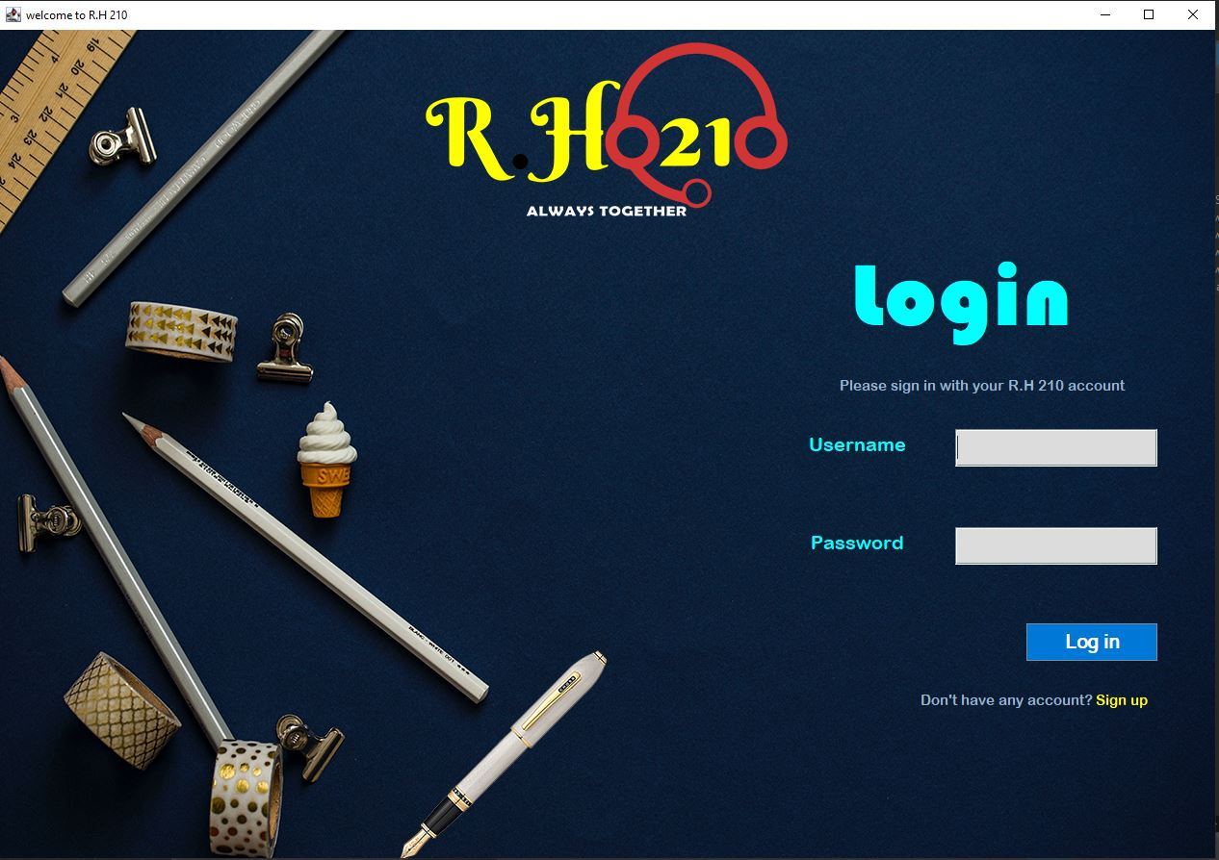

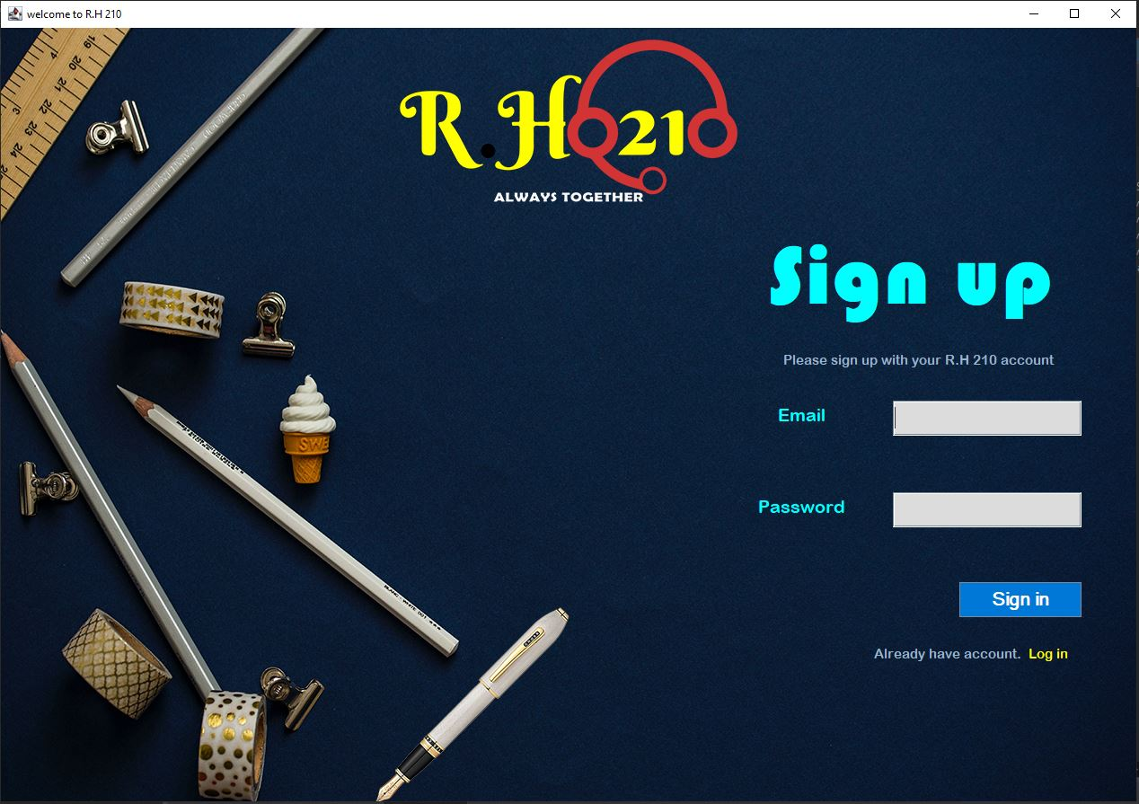

Frame 2

package Login;

import java.awt.*;

import java.awt.event.*;

import java.sql.Connection;

import java.sql.DriverManager;

import java.sql.PreparedStatement;

import javax.swing.*;

import Login.Frame3;

public class Frame2 {

public static void main(String[] args) {

JFrame f2=new JFrame("welcome to R.H 210");

ImageIcon img=new ImageIcon("C:\\Users\\RIFFAQAT ALI\\Desktop\\login\\frame2b.jpg");

//panel of frame

JPanel largepanel = new JPanel();

largepanel.setBounds(0, 0, 1280, 909);

largepanel.setBackground(new Color(0, 0,0, 0));// for transparent background

f2.add(largepanel);

largepanel.setLayout(null);

JLabel title = new JLabel("Learn With Fun");

title.setHorizontalAlignment(SwingConstants.CENTER);

title.setFont(new Font("Tahoma", Font.BOLD | Font.ITALIC, 99));

title.setForeground(Color.YELLOW);

title.setBounds(296, 11, 867, 123);

largepanel.add(title);

//panel of box layout

JPanel panel_1 = new JPanel();

panel_1.setBounds(10, 159, 1248, 714);

panel_1.setBackground(new Color(0, 0,0, 0));

largepanel.add(panel_1);

panel_1.setLayout(new BoxLayout(panel_1, BoxLayout.X_AXIS));//use of box layout

//panel of collecting info of student

//start

JPanel infopanel = new JPanel();

infopanel .setBackground(new Color(0, 0,0, 0));//transparent

panel_1.add(infopanel );

infopanel .setLayout(null);

JLabel name = new JLabel("Name");

name.setBounds(75, 52, 97, 35);

name.setHorizontalAlignment(SwingConstants.CENTER);//make the text in center

name.setFont(new Font("Times New Roman", Font.BOLD, 30));

name.setForeground(new Color(255, 255, 255));

infopanel .add(name);

JTextField uname = new JTextField();

uname.setFont(new Font("Tahoma", Font.PLAIN, 17));

uname.setBounds(281, 52, 187, 35);

infopanel .add(uname);

JLabel son = new JLabel("Son of");

son.setBounds(75, 135, 97, 35);

son.setHorizontalAlignment(SwingConstants.CENTER);

son.setForeground(Color.WHITE);

son.setFont(new Font("Times New Roman", Font.BOLD, 30));

infopanel .add(son);

JTextField sonof = new JTextField();

sonof.setFont(new Font("Tahoma", Font.PLAIN, 17));

sonof.setBounds(281, 208, 187, 35);

infopanel .add(sonof);

JLabel cnic = new JLabel("CNIC");

cnic.setBounds(75, 208, 97, 35);

cnic.setHorizontalAlignment(SwingConstants.CENTER);

cnic.setForeground(Color.WHITE);

cnic.setFont(new Font("Times New Roman", Font.BOLD, 30));

infopanel .add(cnic);

JTextField textFieldcinc = new JTextField();

textFieldcinc.setFont(new Font("Tahoma", Font.PLAIN, 17));

textFieldcinc.setBounds(281, 135, 187, 35);

infopanel .add(textFieldcinc);

JLabel citi = new JLabel("City");

citi.setHorizontalAlignment(SwingConstants.CENTER);

citi.setForeground(Color.WHITE);

citi.setFont(new Font("Times New Roman", Font.BOLD, 30));

citi.setBounds(75, 285, 97, 35);

infopanel .add(citi);

String citynames[] ={"ISLAMABAD", "RAWALPINDI", "LAHORE", "KARACHI", "MULTAN", "KOHAT", "BANU", "HANGU", "QUETTA", "FAISALABAD"};

JComboBox location = new JComboBox(citynames);

location.setFont(new Font("Tahoma", Font.PLAIN, 17));

location.setBounds(281, 285, 187, 35);

infopanel .add(location);

JLabel gender = new JLabel("Gender");

gender.setHorizontalAlignment(SwingConstants.CENTER);

gender.setForeground(Color.WHITE);

gender.setFont(new Font("Times New Roman", Font.BOLD, 30));

gender.setBounds(75, 366, 97, 35);

infopanel .add(gender);

String gend[] ={"select","Male","Female","Other"};

JComboBox g = new JComboBox(gend);

g.setFont(new Font("Tahoma", Font.PLAIN, 17));

g.setBounds(281, 372, 187, 35);

infopanel .add(g);

JLabel cont = new JLabel("Contact");

cont.setHorizontalAlignment(SwingConstants.CENTER);

cont.setForeground(Color.WHITE);

cont.setFont(new Font("Times New Roman", Font.BOLD, 30));

cont.setBounds(33, 453, 187, 35);

infopanel .add(cont);

JTextField phone = new JTextField();

phone.setFont(new Font("Tahoma", Font.PLAIN, 17));

phone.setBounds(281, 453, 187, 35);

infopanel .add(phone);

JLabel qualification = new JLabel("Qualification");

qualification.setHorizontalAlignment(SwingConstants.LEFT);

qualification.setForeground(Color.WHITE);

qualification.setFont(new Font("Times New Roman", Font.BOLD, 30));

qualification.setBounds(57, 534, 187, 35);

infopanel .add(qualification);

String qualific[] ={"O-LEVEL", "MATRIC", "F.SC", "ICS", "BS", "MA"};

JComboBox degree = new JComboBox(qualific);

degree.setFont(new Font("Tahoma", Font.PLAIN, 17));

degree.setBounds(281, 534, 187, 35);

infopanel .add(degree);

JLabel addr = new JLabel("Address");

addr.setHorizontalAlignment(SwingConstants.CENTER);

addr.setForeground(Color.WHITE);

addr.setFont(new Font("Times New Roman", Font.BOLD, 30));

addr.setBounds(57, 618, 147, 35);

infopanel .add(addr);

JTextArea place = new JTextArea();

place.setFont(new Font("Tahoma", Font.PLAIN, 13));

place.setBounds(266, 614, 202, 89);

infopanel .add(place);

//end of info panel

//course info panel

//start

JPanel coursepanel = new JPanel();

coursepanel .setBackground(new Color(0, 0,0, 0));//transparent

panel_1.add(coursepanel );

coursepanel .setLayout(null);

JLabel registration = new JLabel("Registration No");

registration.setHorizontalAlignment(SwingConstants.CENTER);

registration.setForeground(Color.WHITE);

registration.setFont(new Font("Times New Roman", Font.BOLD, 30));

registration.setBounds(62, 60, 235, 35);

coursepanel .add(registration);

JTextField txtRhru = new JTextField();

txtRhru.setFont(new Font("Tahoma", Font.PLAIN, 15));

txtRhru.setText("R-H1432108-RU2022");

txtRhru.setEditable(false);// user cannot change it

txtRhru.setBounds(324, 60, 162, 35);

coursepanel .add(txtRhru);

JLabel batch = new JLabel("Batch No");

batch.setHorizontalAlignment(SwingConstants.CENTER);

batch.setForeground(Color.WHITE);

batch.setFont(new Font("Times New Roman", Font.BOLD, 30));

batch.setBounds(62, 138, 218, 35);

coursepanel .add(batch);

String bn[] ={"Batch_10/june", "Batch_11/july", "Batch_12/august"};

JComboBox btch = new JComboBox(bn);

btch.setFont(new Font("Tahoma", Font.PLAIN, 15));

btch.setBounds(324, 138, 162, 35);

coursepanel .add(btch);

JLabel SHIFT = new JLabel("Course");

SHIFT.setHorizontalAlignment(SwingConstants.CENTER);

SHIFT.setForeground(Color.WHITE);

SHIFT.setFont(new Font("Times New Roman", Font.BOLD, 30));

SHIFT.setBounds(62, 214, 218, 35);

coursepanel .add(SHIFT);

String Shft[] ={"Autocad","Freelancing","Graphics desgning","Wordpress","Web desgning","Youtube SEO","Hacking","Ecommerence","Cyber Security"};

JComboBox timing = new JComboBox(Shft);

timing.setFont(new Font("Tahoma", Font.PLAIN, 17));

timing.setBounds(324, 214, 162, 35);

coursepanel .add(timing);

JLabel coursetype = new JLabel("Course Type");

coursetype.setHorizontalAlignment(SwingConstants.CENTER);

coursetype.setForeground(Color.WHITE);

coursetype.setFont(new Font("Times New Roman", Font.BOLD, 30));

coursetype.setBounds(62, 287, 218, 35);

coursepanel .add(coursetype);

String U[] ={"Long course", "Short course"};

JComboBox ctyp = new JComboBox(U);

ctyp.setFont(new Font("Tahoma", Font.PLAIN, 17));

ctyp.setBounds(324, 287, 162, 35);

coursepanel .add(ctyp);

JLabel med = new JLabel("Medium");

med.setHorizontalAlignment(SwingConstants.CENTER);

med.setForeground(Color.WHITE);

med.setFont(new Font("Times New Roman", Font.BOLD, 30));

med.setBounds(62, 374, 218, 35);

coursepanel .add(med);

String RH[] ={"Live Classes", "Videos"};

JComboBox way = new JComboBox(RH);

way.setFont(new Font("Tahoma", Font.PLAIN, 17));

way.setBounds(324, 374, 162, 35);

coursepanel .add(way);

JLabel language = new JLabel("Course language");

language.setHorizontalAlignment(SwingConstants.CENTER);

language.setForeground(Color.WHITE);

language.setFont(new Font("Times New Roman", Font.BOLD, 30));

language.setBounds(62, 471, 235, 35);

coursepanel .add(language);

String lang[] ={"English", "Urdu", "German", "Arabic", "Spanish","chinese","Latin","Turkish","Greek"};

JComboBox lnguge = new JComboBox(lang);

lnguge.setFont(new Font("Tahoma", Font.PLAIN, 17));

lnguge.setBounds(324, 471, 162, 35);

coursepanel .add(lnguge);

JCheckBox agree = new JCheckBox("I agree to the terms and policy.");

agree.setFont(new Font("Tahoma", Font.PLAIN, 20));

agree.setBackground(SystemColor.activeCaption);

agree.setBounds(93, 556, 393, 48);

coursepanel .add(agree);

JButton submit = new JButton("Submit");

submit.setFont(new Font("SansSerif", Font.BOLD, 20));

submit.setBackground(SystemColor.textHighlight);

submit.setForeground(Color.BLACK);

submit.setBounds(358, 619, 128, 48);

coursepanel .add(submit);

submit.addActionListener(new ActionListener() {

public void actionPerformed(ActionEvent ea) {

Connection con;

try {

Class.forName("net.ucanaccess.jdbc.UcanaccessDriver");

con=DriverManager.getConnection("jdbc:ucanaccess://D:\\userdata.accdb");

System.out.println("connection made");

PreparedStatement stmt=con.prepareStatement("insert into usertable(sn,sf,id,city,gendre,contact,education,address,batchno,shift,courseperiod,medium,courselang)values(?,?,?,?,?,?,?,?,?,?,?,?,?)");

String value1=uname.getText();

stmt.setString(1, value1);

String value2=textFieldcinc.getText();

stmt.setString(2, value2);

String value3=sonof.getText();

stmt.setString(3, value3);

String value4=location.getSelectedItem().toString();

stmt.setString(4, value4);

String value5=g.getSelectedItem().toString();

stmt.setString(5, value5);

String value6=phone.getText();

stmt.setString(6, value6);

String value7=degree.getSelectedItem().toString();

stmt.setString(7, value7);

String value8=place.getText();

stmt.setString(8, value8);

String value9=btch.getSelectedItem().toString();

stmt.setString(9, value9);

String value10=timing.getSelectedItem().toString();

stmt.setString(10, value10);

String value11=ctyp.getSelectedItem().toString();

stmt.setString(11, value11);

String value12=way.getSelectedItem().toString();

stmt.setString(12, value12);

String value13=lnguge.getSelectedItem().toString();

stmt.setString(13, value13);

int a=stmt.executeUpdate();

if(a>0) {

JOptionPane.showMessageDialog(null, "Submitted");

Frame3 f3=new Frame3();

Frame3.main(null);

f2.dispose();

System.out.println("recored inserted");

}

else

System.out.println("reocred failed");

}

catch(Exception e) {

System.out.println(e);

}

}

});

//background image

JLabel l=new JLabel("",img,JLabel.CENTER);

l.setBounds(0, 0, 1280, 909);

//frame

f2.add(l);

f2.setVisible(true);f2.setSize(1280, 940);

}

}

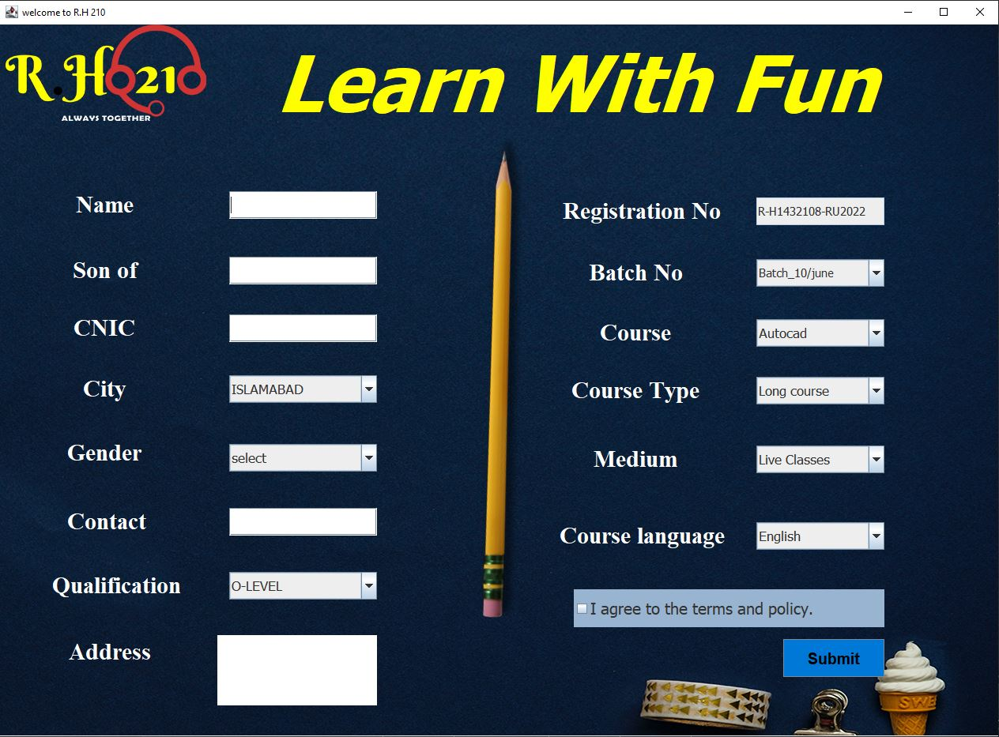

Frame3

package Login;

import java.awt.*;

import java.awt.event.*;

import java.sql.Connection;

import java.sql.DriverManager;

import java.sql.PreparedStatement;

import java.sql.ResultSet;

import javax.swing.*;

import net.proteanit.sql.DbUtils;

public class Frame3 {

public static void main(String[] args) {

// TODO Auto-generated method stub

JFrame f3=new JFrame("welcome to R.H 210");

ImageIcon img=new ImageIcon("C:\\Users\\RIFFAQAT ALI\\Desktop\\login\\frame3a.jpg");

JPanel panel = new JPanel();

panel.setBackground(new Color(0, 0,0, 0));

panel.setBounds(0, 0, 1264, 821);

f3.add(panel);

panel.setLayout(new BorderLayout(0, 0));

JPanel titlepanel = new JPanel();

titlepanel .setBackground(new Color(0, 0,0, 0));

panel.add(titlepanel , BorderLayout.NORTH);

JLabel lblNewLabel = new JLabel("Students enrolled list");

lblNewLabel.setForeground(Color.YELLOW);

lblNewLabel.setHorizontalAlignment(SwingConstants.CENTER);

lblNewLabel.setFont(new Font("Serif", Font.PLAIN, 45));

titlepanel .add(lblNewLabel);

JPanel footer = new JPanel();

footer.setBackground(new Color(0, 0,0, 0));

panel.add(footer, BorderLayout.SOUTH);

footer.setLayout(new FlowLayout(FlowLayout.CENTER, 180, 00));

JButton btnNewButton_1 = new JButton("Add new Course");

btnNewButton_1.setForeground(new Color(216, 250, 8));

btnNewButton_1.setHorizontalAlignment(SwingConstants.LEFT);

btnNewButton_1.setBackground(new Color(44, 62, 80));

btnNewButton_1.setFont(new Font("Arial Rounded MT Bold", Font.BOLD, 20));

btnNewButton_1. addActionListener(new ActionListener(){

public void actionPerformed(ActionEvent e){

f3.dispose();Frame2 f2=new Frame2();

Frame2.main(null);

}

});

footer.add(btnNewButton_1);

JLabel lblNewLabel_1 = new JLabel("Thanks for choosing us");

lblNewLabel_1.setForeground(Color.YELLOW);

lblNewLabel_1.setHorizontalAlignment(SwingConstants.LEFT);

lblNewLabel_1.setFont(new Font("Disorder", Font.BOLD | Font.ITALIC, 30));

footer.add(lblNewLabel_1);

JButton btnNewButton_1_1 = new JButton("Finsh");

btnNewButton_1_1.setForeground(new Color(216, 250, 8));

btnNewButton_1_1.setHorizontalAlignment(SwingConstants.RIGHT);

btnNewButton_1_1.setBackground(new Color(44, 62, 80));

btnNewButton_1_1.setFont(new Font("Arial Rounded MT Bold", Font.BOLD, 20));

btnNewButton_1_1. addActionListener(new ActionListener(){

public void actionPerformed(ActionEvent e){

f3.dispose()

;

}

});

footer.add(btnNewButton_1_1);

JPanel p1 = new JPanel();

panel.add(p1, BorderLayout.CENTER);

p1.setBackground(new Color(0, 0,0, 0));

p1.setLayout(null);

JButton b1 = new JButton("Search by Name");

b1.setForeground(new Color(216, 250, 8));

b1.setHorizontalAlignment(SwingConstants.CENTER);

b1.setBackground(new Color(44, 62, 80));

b1.setFont(new Font("Arial Rounded MT Bold", Font.BOLD, 20));

JTextField t1 = new JTextField();

JButton b2 = new JButton("Display List ");

b2.setForeground(new Color(216, 250, 8));

b2.setHorizontalAlignment(SwingConstants.CENTER);

b2.setBackground(new Color(44, 62, 80));

b2.setFont(new Font("Arial Rounded MT Bold", Font.BOLD, 20));

b1.setBounds(38, 98, 229, 43);

b2.setBounds(1017, 98, 203, 43);

t1.setBounds(293, 98, 172, 43);

p1.add(b1);

p1.add(t1);

p1.add(b2);

JTable t = new JTable();

t.setBackground(Color.LIGHT_GRAY);

JScrollPane scrollPane = new JScrollPane();

scrollPane.setBounds(38, 194, 1182, 532);

p1.add(scrollPane);

scrollPane.setViewportView(t);

b2.addActionListener(new ActionListener() {

public void actionPerformed(ActionEvent e) {

Connection con = null;

PreparedStatement pst = null;

ResultSet rs = null;

try {

Class.forName("net.ucanaccess.jdbc.UcanaccessDriver");

con = DriverManager.getConnection("jdbc:ucanaccess://D:\\userdata.accdb");

String query = "select * from usertable";

pst = con.prepareStatement(query);

rs = pst.executeQuery();

t.setModel(DbUtils.resultSetToTableModel(rs));

}

catch (Exception ex) {

JOptionPane.showMessageDialog(null, ex.getMessage());

}

}

});

b1.addActionListener(new ActionListener() {

public void actionPerformed(ActionEvent e) {

Connection con = null;

PreparedStatement pst = null;

ResultSet rs = null;

Boolean data = false;

try {

Class.forName("net.ucanaccess.jdbc.UcanaccessDriver");

con = DriverManager.getConnection("jdbc:ucanaccess:///D:\\userdata.accdb");

String query = "select * from usertable where sn=?";

pst = con.prepareStatement(query);

pst.setString(1,t1.getText() );

rs = pst.executeQuery();

if (!rs.isBeforeFirst() ) {

JOptionPane.showMessageDialog(null, "No Record Found");

t1.setText("");

}

else {

t.setModel(DbUtils.resultSetToTableModel(rs));

t1.setText("");

}

}

catch (Exception ex) {

JOptionPane.showMessageDialog(null, ex.getMessage());

}

}

});

JLabel l=new JLabel("",img,JLabel.CENTER);

l.setBounds(0, 0, 1280, 860);

f3.add(l);

f3.setVisible(true);f3.setSize(1280, 860);

}

}

